Create And Configure IBM Cloud Services

|  |  |
| --- | --- |
| DATE | 18 November 2022 |
| TEAM ID | PNT2022TMID42645 |
| PROJECT NAME | Hazardous Area Monitoring for Industrial Plants powered by IOT |

Create IBM Iot platform And Device:

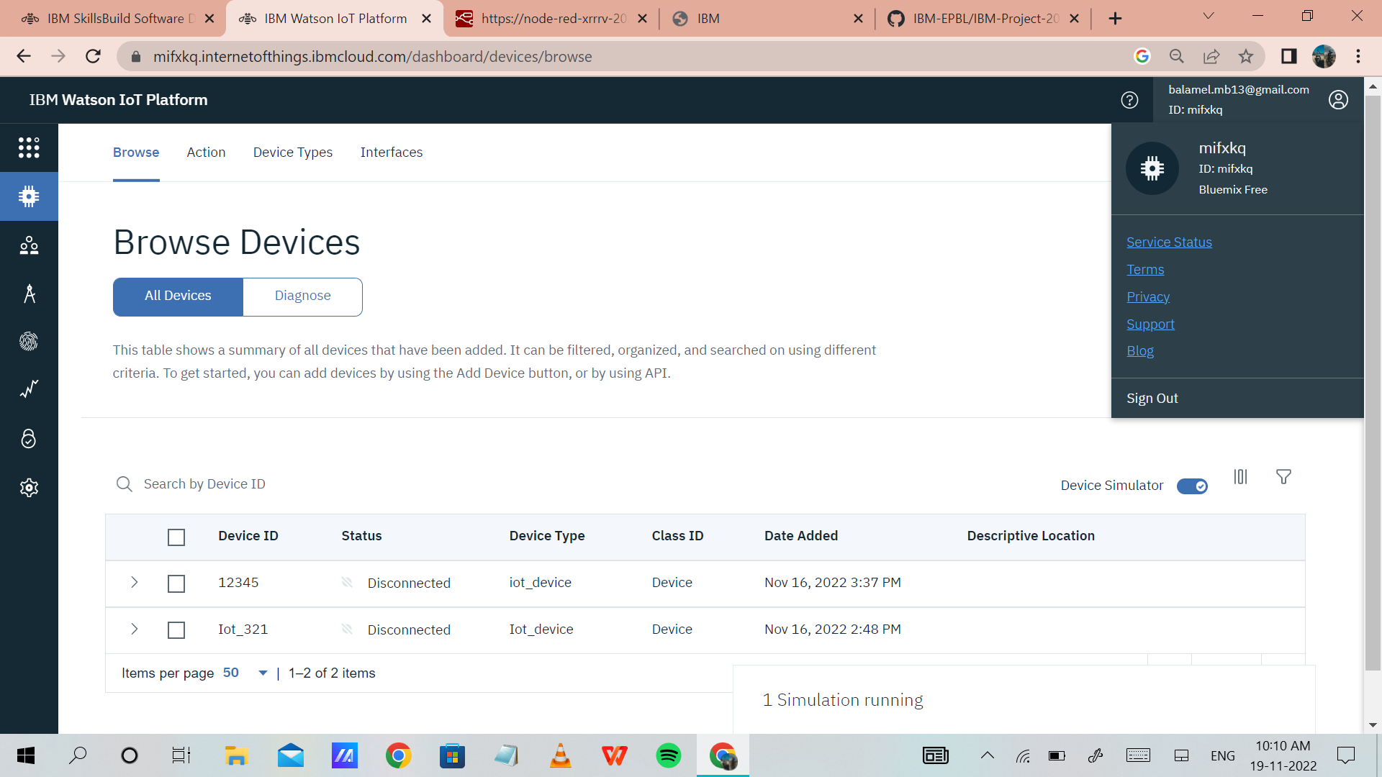

Create Node-Red Services:

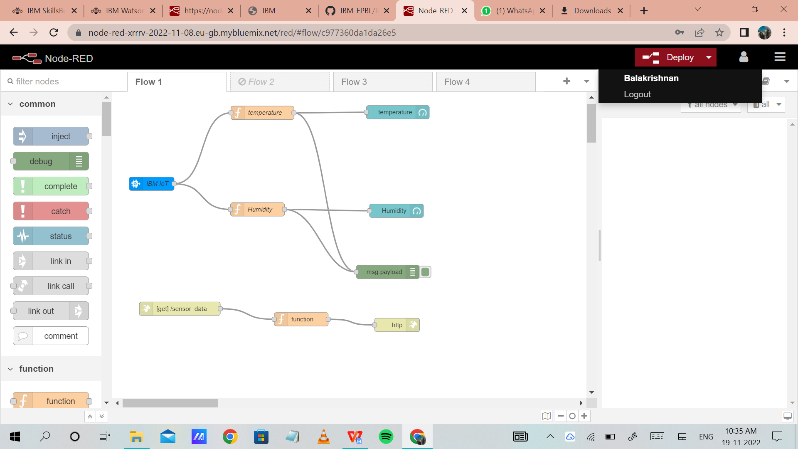

Cloudant:

